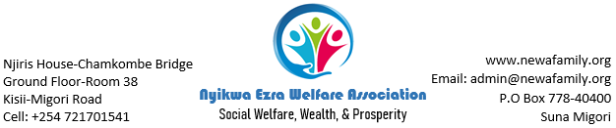
[Date]
[Recipient Name], [Title]
[Company]
[Street Address]
[City, ST Zip Code]
Dear [Recipient Name]
[If you’re ready to write, select a line or paragraph of tip text and start typing to replace it with your own. Don’t include space to the right of the characters in your selection.]
[It’s easy to match any of the text formatting you see here. On the Home tab of the ribbon, check out the Styles gallery for all styles used in this letter.]
Looking to change the colors to better match your personal taste? Easy! Go to the Design tab and choose a color palette that you like from the Colors menu. Hovering over the different palettes will show you what your document would look like with the new palette.
Make a formatting change to the colors or fonts that you don’t like? Just go back to the Design tab and select the Theme menu. From there, choose the option to reset to the original template theme.
Sincerely,
[Your Name]

